The Little Old Lady
Who Wasn’t Afraid of Anything

Watch and listen to this spooky tale:
https://safeshare.tv/x/RiRDefBwZM

While you listen to the story, copy the motions of each different piece of enchanted clothing.
How can you show the actions of the clothes with your body?
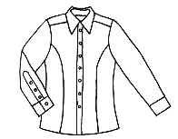
Shoes: Clomp, clomp
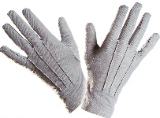
Pants: Wiggle, wiggle
Shirt: Shake, shake
Gloves: Clap, clap
Hat: Nod, nod
Pumpkin: BOO!

Explain to a family member why the music gets faster as the story goes along.

Hall of the Mountain King
"In the Hall of the Mountain King" is a piece of orchestral music composed by Edvard Grieg in 1875.
Listen to the piece of music here:
https://www.youtube.com/watch?v=kLp_Hh6DKWc&t=29s

Let your body listen to and move along with the music.
What happens to the speed and volume of the music as the song continues?

Writing a Musical Story
At home, you can create your own story based on the music of Hall of the Mountain King. You may need to ask a family member or an older sibling to help as you create your story.

- Listen to the music again while seated. Make a list of words/ideas that describe the feelings and emotions of the music.

- Create an original character to be the main character in your story. Is the character a person, animal or other kind of creature? Where does the story take place? Brainstorm and write down your ideas, then draw a picture of your character.

- Where does your story take place? Is it a real location, or made up?

- As you listen to the song, what do you imagine is happening in the story? How does the music show this? How does your story end? Brainstorm and write down your ideas. You can draw a picture of the setting and the events of your story if you choose.

