3D WORRY MONSTERS

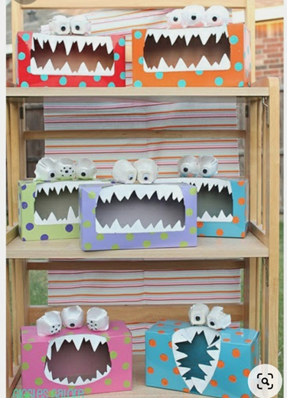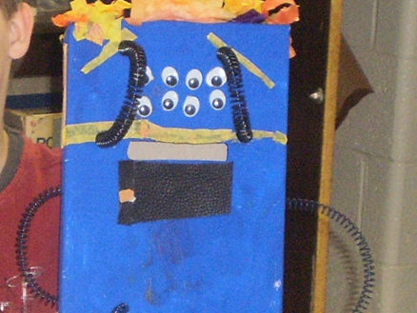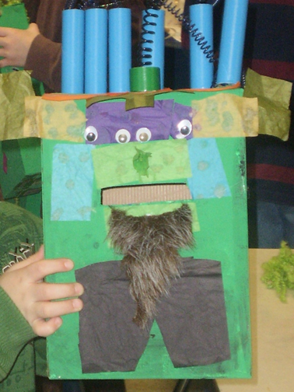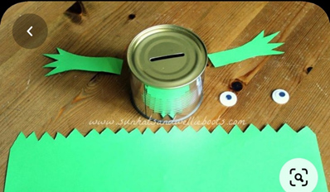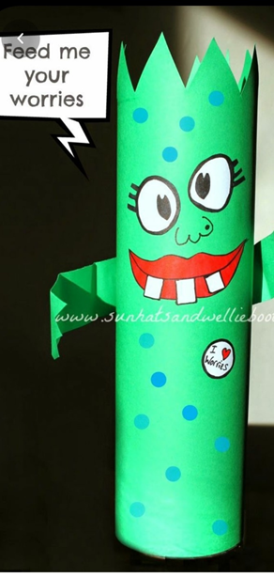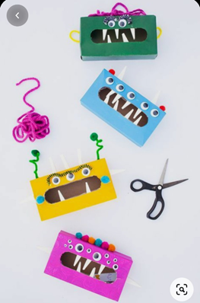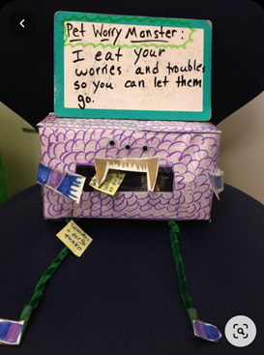
Materials
Cereal box, Kleenex box, Amazon box, toilet paper tube, any cardboard box
Colorful paper
Eyes, feathers, pipe cleaners, misc. Supplies
Glue
Markers, crayons, paint, etc...
Creating a worry monster for young students is a great way for children to express their thoughts and emotions. Make the monster using any box as you can cut out a mouth. A cereal box, a Kleenex box, a toilet paper tube, any cardboard box, and more…Create the monster using paper, eyes, feathers, pipe cleaners, anything you have at home that will work. You could also make an animal, unicorn, shark, dinosaur, or whatever else may be more engaging for the child instead of a monster.
Parent Prompt: Talk about worries or “thinking” with the child and have them identify some worries, thoughts, frustrations, etc. that they would like to not think of in that moment.
Have the child write or draw their worries on pieces of paper and notice the worry or thought and talk about it if they choose to. It’s also helpful to let the child know they can simply notice their thoughts without talking about it. After they have noticed and written down the worry or thought, they can choose to let it go by feeding it to the monster! They can pretend to take thoughts out of their head and throw them into the box for when they don’t have paper.
This can also be used for children who struggle expressing their anger safely. They can write down things that make them angry that they would like to let go of. This can help in identifying triggers and expressing anger in safer ways, simply by writing or drawing about it and feeding it to their monster.

